Development near Sewell's Falls grows to a proposed 944 housing units
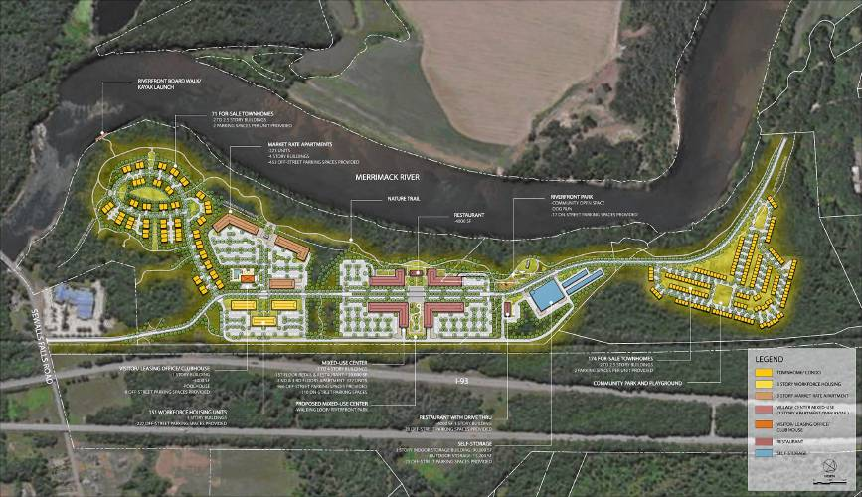
Monitor Way development conceptual plan, October 2023 - Community PowerMonitor Way
By DAVID BROOKS  Monitor staff | Published: 10-17-2023 - 11:09:38
A proposed development at Sewall's Falls in north Concord has grown to 944 apartments, condominiums and townhouses, an increase of almost 50% since it was informally presented last summer.
The project, called Monitor Way because much of it would be built on land alongside the Concord Monitor building on Sewalls Falls Road, seeks to build 151 workforce housing units, 327 market-rate apartments within a mixed-use retail center, 223 standalone market-rate apartments, 71 townhouses for sale and 172 condominiums for sale and rent. It would also feature over 100,000 square feet of commercial retail space and another 100,000 square feet of self-storage space.
The conceptual plan calls for buildings to be spaced out around a new road that runs along the east bank of the Merrimack River between Sewalls Falls Road and Exit 17 of I-93.
The project is one of a number of large, mixed-use developments that have been proposed or are being developed in Concord recently. Two of these Monitor Way and the proposal to replace Steeplegate Mall with625 apartments and various shops and restaurants will come before the Planning Board on Wednesday night for their first conceptual design review, the beginning of what will probably be a lengthy process before final approval.
Monitor Way developers estimate it could generate "more than $6 million" in annual property tax revenue. The area is currently zoned for industrial use and will require approval from the Concord City Council at a later date to rezone the land to allow for mixed-use development.
The site includes 95 acres owned by Newspapers of New England, the Monitor's parent company, and 40 acres owned by the Concord Regional Solid Waste Co-op.
The proposal is part of a statewide trend of large, mixed-use developments in which residents can walk to some stores and services, instead of housing-only complexes where everybody has to drive everywhere.
Concord is seeing a flurry of housing proposals currently more than 1,900 units, mostly apartments have been proposed in several areas of the city. They include about 200 apartments in the Rail Yard in the city's South End off Langdon Avenue, which may start renting in the first phase this fall; a proposal off Manchester Street near Exit 13 of Ineterstate 93at the site of the former Concord Drive-in, which would have 266 apartments plus 24 townhomes; and several housing developments such as the 54 units replacing the former Employment Security building on S. Main St., and 59 units of various types near Exit 1 off I-89 in Bow, just south of the city line.
Elsewhere in the state, Londonderry is looking at a proposal for 300 apartments on 90 acres in what developers are calling a "mixed-use village" as well as Woodmont Commons, which could end up with 1,400 housing units amid offices and shops, while in Salem, the 170-acre Tuscan Village on the site of the former Rockingham Park racetrack aims to build as many as 1,700 apartments and condominiums.
New Hampshire Housing's annual report says the state needs roughly 20,000 more housing units to create enough vacancies and stabilize costs. Down the road, it estimates New Hampshire needs closer to 90,000 new units by 2040.

